# 

# CSC 431 Train Tracker: Miami Dade Software Requirements Specification (SRS)

**Team 1**

|  |  |
| --- | --- |
| Spencer Terwilliger | Risk Managment |
| Ben Oberg | **Front-End Developer** |
| Jacob Smyth | **Back-End Developer** |
|  |  |

# Version History

|  |  |  |  |
| --- | --- | --- | --- |
| Version | Date | Author(s) | Change Comments |
| 1.1 | 02/20/2023 | Ben  Spencer  Jacob | First Draft |
| 1.2 | 05/05/2023 | Ben  Spencer  Jacob | Second Draft |
|  |  |  |  |
|  |  |  |  |

# Table of Contents

[1. System Requirements](applewebdata://08A51D70-10DC-483E-9264-A5463AD4383C#_Toc412649646)

[1.1 Functional Requirements](applewebdata://08A51D70-10DC-483E-9264-A5463AD4383C#_Toc412649647)

1.1.1 Create Account

1.1.2 Logging In

1.1.3 View Home Page

1.1.4 Search Train Stations

1.1.5 Displaying Arrival and Departing Times

1.1.6 Entering Arrival and Departing Times

1.1.7 Update Changes to Train Schedule

1.1.8 Update User Through Push Notifications

1.1.9 Suggest Routes

1.1.10 User Double Checks Accuracy

[1.2 Non-Functional Requirements](http://applewebdata://08A51D70-10DC-483E-9264-A5463AD4383C#_Toc412649649)

1.2.1 Time to Display Times

1.2.4 Login Security

1.2.5 Network Security

[2. System Constraints](applewebdata://08A51D70-10DC-483E-9264-A5463AD4383C#_Toc412649651)

[2.1 Tool Constraints](applewebdata://08A51D70-10DC-483E-9264-A5463AD4383C#_Toc412649652)

2.1.1 Microsoft SQL Server

2.1.2 React

2.1.3 Spring

[2.2 Language Constraints](applewebdata://08A51D70-10DC-483E-9264-A5463AD4383C#_Toc412649654)

2.2.1 React JS

2.2.2 SQL

[2.3 Platform Constraints](applewebdata://08A51D70-10DC-483E-9264-A5463AD4383C#_Toc412649656)

2.3.1 App Store

[2.4 Hardware Constraints](applewebdata://08A51D70-10DC-483E-9264-A5463AD4383C#_Toc412649658)

2.4.1 Smart Phone

[2.5 Network Constraints](applewebdata://08A51D70-10DC-483E-9264-A5463AD4383C#_Toc412649660)

2.5.1 Valid Network Connection

[2.6 Deployment Constraints](applewebdata://08A51D70-10DC-483E-9264-A5463AD4383C#_Toc412649662)

2.6.1 Adopting New System

[2.7 Transition & Support Constraints](applewebdata://08A51D70-10DC-483E-9264-A5463AD4383C#_Toc412649664)

2.7.1 Existing Systems

[2.8 Budget & Schedule Constraints](applewebdata://08A51D70-10DC-483E-9264-A5463AD4383C#_Toc412649666)

2.8.1 Budget Constraints

[3. Requirements Modeling](applewebdata://08A51D70-10DC-483E-9264-A5463AD4383C#_Toc412649670)

3.1.1 System Use Case Diagram

[4. Evolutionary Requirements](applewebdata://08A51D70-10DC-483E-9264-A5463AD4383C#_Toc412649672)

[4.1 Functional Requirements](applewebdata://08A51D70-10DC-483E-9264-A5463AD4383C#_Toc412649673)

4.1.1 Add Additional Stations

[4.2 Non-Functional Requirements](applewebdata://08A51D70-10DC-483E-9264-A5463AD4383C#_Toc412649675)

4.2.1 Keep Data Accurate

# Table of Figures

[3.1.1 Requirements Modeling System use case diagram](#_3.1.1   _System_Use)

### 1. System Requirements

#### 1.1 Functional Requirements

##### 1.1.1 Create Account

|  |  |
| --- | --- |
| Title | Create Account |
| Description | The user will be prompted to create an account to store data relevant to them. For workers it will be the station they work at while users it shall be the stations, they frequent the most. |
| Priority | 0 |
| Precondition(s) | The user will need an email account in order to sign up |
| Basic Flow | * User opens application * If they are a first-time user, they are prompted to create an account * The user will then fill out their information and create an account |
| Postconditions(s) | They will now have an account to store their information |
| Use Case Diagram | <Link or number, if present> |

##### 1.1.2 Logging In

|  |  |
| --- | --- |
| Title | Allow users to log in |
| Description | Users with existing accounts will be able to log in to their accounts. |
| Priority | 0 |
| Precondition(s) | The user will need to have an account already created |
| Basic Flow | * User opens application * The user will click on the prompt to log in * The user will then enter their username and password * If they forget their password there will be an option to reset it * After the user signs in they will be redirected to the app |
| Postconditions(s) | The user will be logged into the app |
| Use Case Diagram | <Link or number, if present> |

##### 1.1.3 View Home Page

|  |  |
| --- | --- |
| Title | View Home Page |
| Description | When the user first opens the app after logging in, they should be greeted at the home page. This page should include information about delays or schedule changes. |
| Priority | 0 |
| Precondition(s) | The user needs to be logged into their account |
| Basic Flow | * The user opens the app * They log in or create an account if they must * They then see the home page |
| Postconditions(s) | The user is on the home page ready to use the app as they desire |
| Use Case Diagram | <Link or number, if present> |

##### 1.1.4 Search Train Stations

|  |  |
| --- | --- |
| Title | Search for desired train station |
| Description | This feature will allow users to select the train station that they wish to receive arrival and departing times for |
| Priority | 0 |
| Precondition(s) | The user will need to have an account |
| Basic Flow | * The user opens the app * If they are not logged in, they must do so * Then they will search for their desired train station |
| Postconditions(s) | The user will be on the page for their desired train station |
| Use Case Diagram | <Link or number, if present> |

##### 1.1.5 Displaying Arrival and Departing times

|  |  |
| --- | --- |
| Title | Arrival and Departing times |
| Description | Our app should display the arrival and departing times of trains. The user should be able to select the station and train they want. |
| Priority | 0 |
| Precondition(s) | The user needs to download the app, open it up, and enable location services or manually enter a location. |
| Basic Flow | * User opens up the app * User selects the train station they wish to see times for * User selects which train they wish to see information for |
| Postconditions(s) | User is asked to determine if the arrival and departing times are accurate |
| Use Case Diagram | 3.1 |

##### 1.1.6 Entering Arrival and Departing Times

|  |  |
| --- | --- |
| Title | Entering arrival and departing times |
| Description | The train station workers will need to enter the estimated arrival and departing times displayed at the station. |
| Priority | 0 |
| Precondition(s) | The worker should have a verified account on the app which allows them to enter information about arrival and departing times. |
| Basic Flow | * Worker opens app * Worker signs into their account * Workers chooses the station they are working at * Worker enters the arrival and departing times |
| Postconditions(s) | The arrival and departing times should be posted on the app. |
| Use Case Diagram | 3.2 |

##### 1.1.7 Update Changes to Train Schedule

|  |  |
| --- | --- |
| Title | Update changes to train schedule |
| Description | Train station workers should be able to create alerts about changes to the train schedule or delays. Users should receive said alert when they open up the app. |
| Priority | 3 |
| Precondition(s) | The worker should have a verified account on the app which allows them to create these alerts. |
| Basic Flow | * Worker opens app * Worker signs into their account * Worker creates the alert |
| Postconditions(s) | The alert is visible for users when they open the app |
| Use Case Diagram | 3.3 |

##### 1.1.8 Update User Through Push Notifications

|  |  |
| --- | --- |
| Title | Push Notifications |
| Description | Sending real time notifications of train arrival and departures, scheduling changes and delays and cancellations |
| Priority | 3 |
| Precondition(s) | The worker should have a verified account on the app which allows them to create these alerts. |
| Basic Flow | * Worker opens app * Worker signs into their account * Worker creates the alert |
| Postconditions(s) | The alert is visible for users when they open the app |
| Use Case Diagram | 3.3 |

##### 1.1.9 Suggest Routes

|  |  |
| --- | --- |
| Title | Suggest routes |
| Description | Our app should suggest a variety of routes based on current location and previously taken trains |
| Priority | 1 |
| Applicable FR(s) |  |

##### 1.1.10 Users Double Check Accuracy

|  |  |
| --- | --- |
| Title | Users Double Check Accuracy |
| Description | Users should be able to confirm or deny whether the times are accurate. The app should analyze and change times if they are inaccurate |
| Priority | 1 |
| Applicable FR(s) |  |

#### 1.2 Non-Functional Requirements

##### 1.2.1 Time to Display Times

|  |  |
| --- | --- |
| Title | Time to display times |
| Description | Our app should take no longer than 5 seconds to fetch and display the arrival and departing times for the requested station. |
| Priority | 1 |
| Applicable FR(s) | Displaying arrival and departing times |

##### 1.2.2 Login Security

|  |  |
| --- | --- |
| Title | Login security |
| Description | All of our user data should be encrypted to protect the user |
| Priority | 1 |
| Applicable FR(s) |  |

##### 1.2.3 Network Security

|  |  |
| --- | --- |
| Title | Network Security |
| Description | Our app should have a strong network that is not susceptible to hacking attacks |
| Priority | 1 |
| Applicable FR(s) |  |

### 2. System Constraints

#### 2.1 Tool Constraints

##### 2.1.1 Microsoft SQL Server

|  |  |
| --- | --- |
| Title | Microsoft SQL Server |
| Description | We will be using Microsoft's SQL Server to store and retrieve the necessary data. |
| Priority | 0 |

##### 2.1.2 React JS

|  |  |
| --- | --- |
| Title | React |
| Description | We will be using React JS to create the front-end framework for our app. |
| Priority | 0 |

##### 2.1.3 Spring

|  |  |
| --- | --- |
| Title | Spring |
| Description | We will be Spring to create our back-end framework |
| Priority | 0 |

#### 2.2 Language Constraints

##### 2.2.1 React JS

|  |  |
| --- | --- |
| Title | React JS |
| Description | To implement the front-end of our mobile app we will be using React JS. We are using this because JavaScript framework works on multiple mobile operating systems. This will allow us to create an efficient app for all users. |
| Priority | 0 |

##### 2.2.1 Microsoft SQL Server

|  |  |
| --- | --- |
| Title | SQL |
| Description | We will be coding our database using SQL |
| Priority | 0 |

#### 2.3 Platform Constraints

##### 2.3.1 App Store

|  |  |
| --- | --- |
| Title | App store |
| Description | The app will be released on IOS and android App stores |
| Priority | 2 |

#### 2.4 Hardware Constraints

##### 2.4.1 Smart Phone

|  |  |
| --- | --- |
| Title | Smart phone |
| Description | A smartphone with an app store is required to be able to download the app |
| Priority | 2 |

#### 2.5 Network Constraints

##### 2.5.1 Valid Network Connection

|  |  |
| --- | --- |
| Title | A network connection to the web is required |
| Description | Our app utilizes network connectivity in order to provide real time information |
| Priority | 2 |

#### 2.6 Deployment Constraints

##### 2.6.1 Adopting New System

|  |  |
| --- | --- |
| Title | Adopting new system |
| Description | There will be an initial delay as we wait to work out contracts with Miami Dade train stations |
| Priority | 2 |

#### 2.7 Transition & Support Constraints

##### 2.7.1 Existing Systems

|  |  |
| --- | --- |
| Title | Existing systems |
| Description | Existing train scheduling and tracking software may need to be updated to be able to transmit information to our app |
| Priority | 3 |

#### 2.8 Budget & Schedule Constraints

##### 2.8.1 Budget Constraint

|  |  |
| --- | --- |
| Title | Budget |
| Description | To stay under the budget defined by the stakeholder |
| Priority | 1 |

##### 2.8.2 Scheduling Constraint

|  |  |
| --- | --- |
| Title | Scheduling |
| Description | To have the project completed by the specified time defined by the stakeholder |
| Priority | 1 |

### 3. Requirements Modeling

##### 3.1.1 System Use Case Diagram

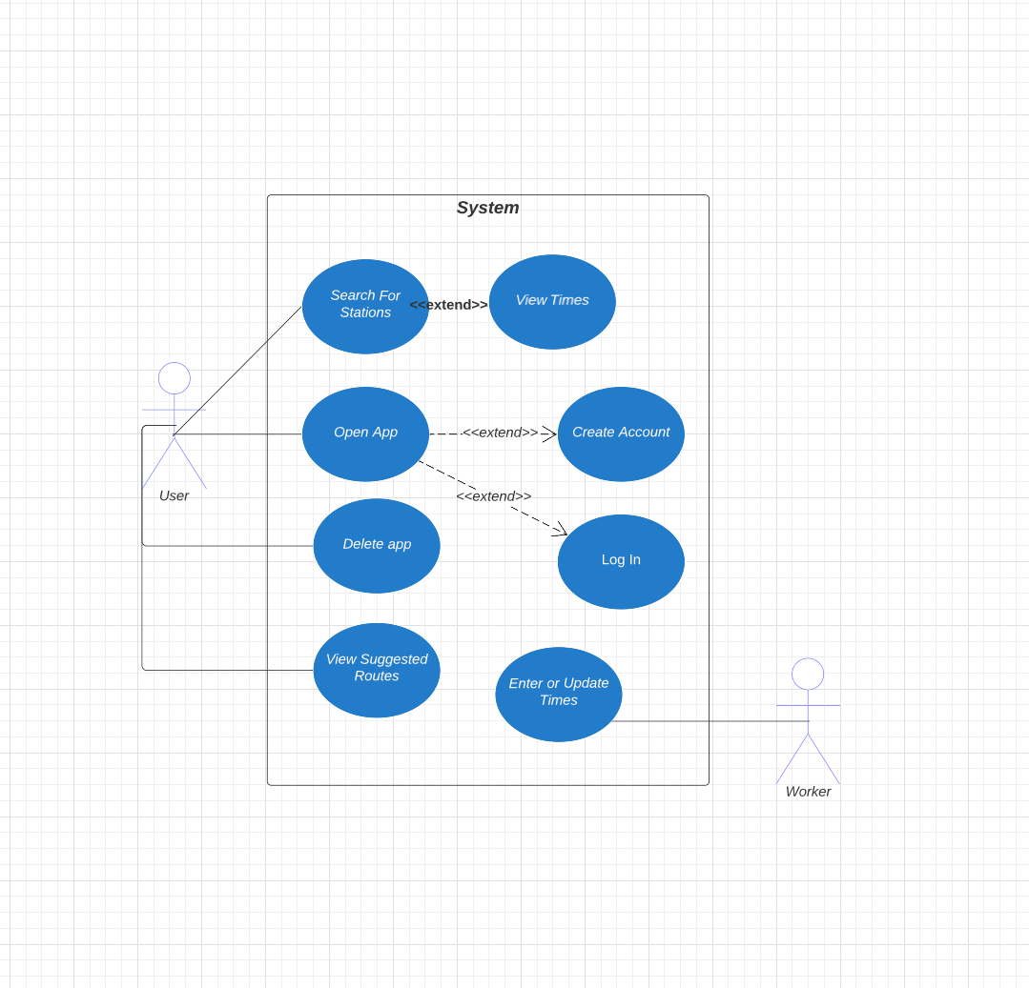

### 4. Evolutionary Requirements

#### 4.1 Functional Requirements

##### 4.1.1 Add Additional Stations

|  |  |
| --- | --- |
| Title | Additional stations being added |
| Description | At time of deployment a set number of participating stations are set and more will be added in future updates. |
| Priority | 3 |
| Precondition(s) | Getting a small group of participating stations to adopt our app for relaying real time train information |
| Postconditions(s) | More stations in future updates will be added to the apps support |
| Use Case Diagram | <Link or number, if present> |

#### 4.2 Non-Functional Requirements

##### 4.2.1 Preserve Data Reliability

|  |  |
| --- | --- |
| Title | Data and security up to date |
| Description | Our application should have frequent updates in order to maintain accurate and efficient arrival and departure times. This can also include user security. |
| Priority | 3 |
| Applicable FR(s) |  |